INTERNSPARK INTERNSHIP
Static Timing Analysis (STA) & Timing Closure
Task 3

Name | Budde Rohini
Title | Static Timing Analysis(STA) & Timing Closure

Objective
The objective of this task is to study and perform Static Timing Analysis (STA) on a synthesizable RTL design (sta_design), a clocked 4-bit adder. The design is first functionally verified through RTL simulation, after which it is taken through synthesis and timing analysis to check that the implementation meets the required clock period, with no setup or hold time violations on any timing path.

Design Description
The sta_design module has three inputs — clk, rst, a[3:0] and b[3:0] — and a single registered 5-bit output sum[4:0]. On every positive edge of the clock: if rst is asserted, the output is synchronously cleared to 0; otherwise the output register latches the sum of the two 4-bit operands, a + b. Because the addition is registered, the combinational adder logic between the input registers and the output register forms the critical timing path that is analysed during STA. A self-checking testbench (sta_design_tb) generates a periodic clock, applies reset, and then drives a sequence of operand values through a and b, monitoring the resulting sum at every transition.

Deliverables
- RTL source file (sta_design.v) and self-checking testbench (sta_design_tb.v).
- Functional simulation waveform showing clk, rst, a[3:0], b[3:0] and sum[4:0].
- Console / signal value monitor confirming correct arithmetic operation for all test vectors.
- Synthesis of the RTL followed by Static Timing Analysis — setup/hold checks, critical path delayand slack analysis against the target clock period.

Tools Used
Verilog HDL for RTL coding, a simulator (ModelSim / Vivado Simulator) for functional simulation, and a synthesis & static timing analysis tool (Vivado / Design Compiler / OpenSTA / PrimeTime) for gate-level synthesis and timing closure.

Source code
The Verilog module below implements a clocked 4-bit adder with synchronous reset. The combinational path computing a + b, registered at sum, is the path of interest for static timing analysis.
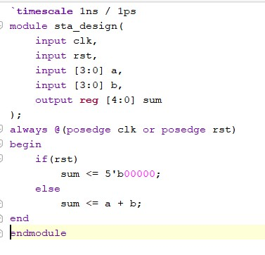
Fig. 1 — sta_design RTL module (Verilog)

2. Testbench — sta_design_tb.v

Test Bench code:
The testbench instantiates the design under test (sta_design), generates a clock with a 10 ns period (toggling every 5 ns), and declares register/wire signals to drive and observe the DUT.
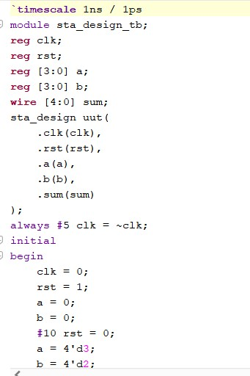
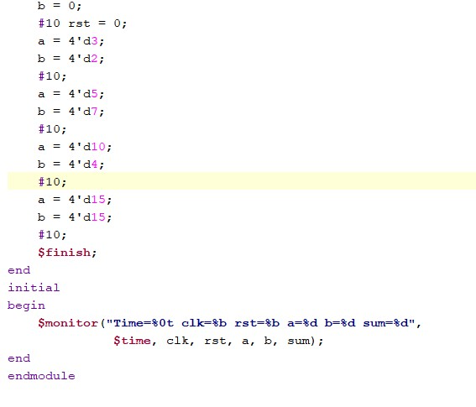
Fig. 3 — Stimulus generation, monitor statement and $finish

3. Functional Simulation Waveform
The waveform below shows clk, rst, a[3:0], b[3:0] and sum[4:0] over the simulation run. The output sum correctly updates to a + b on each clock edge after reset is released, confirming correct functional behaviour of the adder before proceeding to synthesis and timing analysis.
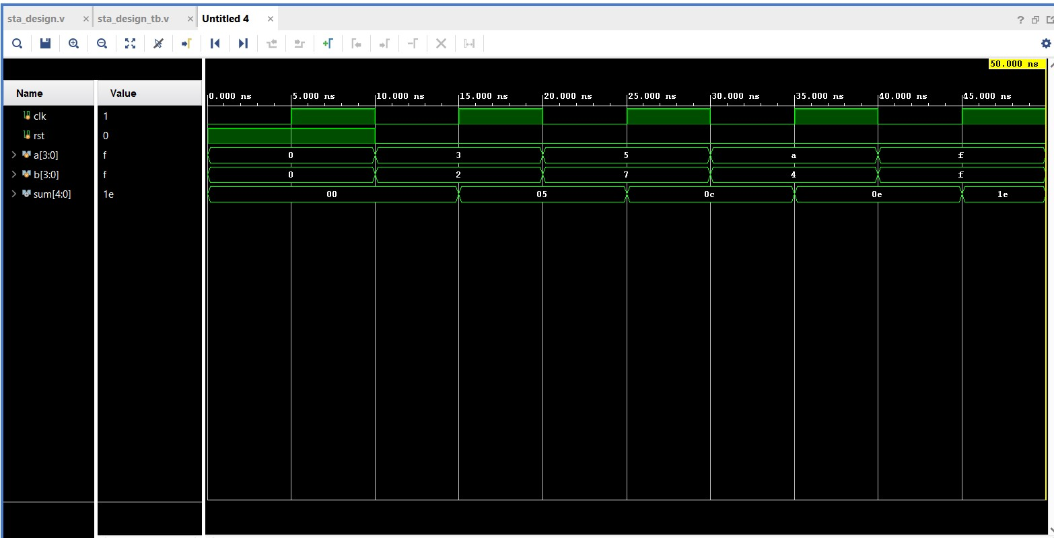
Fig. 4 — Simulation waveform (signal timing diagram)
The table below is a snapshot of signal values at a sampled simulation time, captured from the waveform viewer's Objects panel.
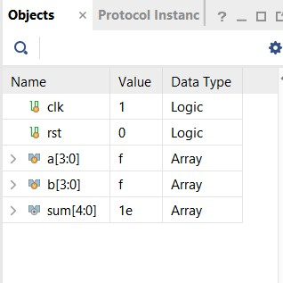
Fig. 5 — Sampled signal values (clk, rst, a, b, sum)

Overall summary:
The diagram below summarises the general RTL design, functional-simulation and synthesis methodology that was followed for this task — from requirements analysis and RTL coding through testbench creation, functional simulation, coverage analysis and final RTL/gate-level verification.
